Dan Rice Days Contest

How would you decorate this?

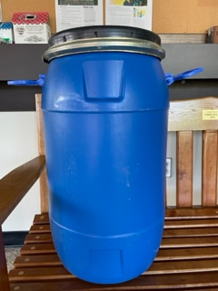

Could it be a minion
an ocean of fish?
The possibilities are endless.

If you would like to participate, the containers are at the Girard Borough Building. Pick one up and decorate your container. Return it and a registration form by August 1st. Monetary prizes will be awarded for 1st, 2nd, and 3rd place.

